BY-LAWS – In order to get involved in the FEP activities, a Finnish organisation or association abroad ratifies FEP By-laws. After ratification, the organization can send its representative(s) to the FEP Sessions and submit initiatives to it.
SPEAKERS – The Chairman of the Finland Society is the Speaker of the Parliament. The Parliament Session elects eight Deputy Speakers, who represent different world regions. The Speakers’ Council, consisting of the Speaker and the Deputy Speakers, meets twice a year in Helsinki.
SESSIONS – The FEP convenes every 2-3 years to a parliamentary Session in Helsinki. The 20th anniversary Session in 2017 adopted 56 resolutions. The 10th Session was postponed by one year and convened digitally, long-distance in June 2021. It adopted 70 resolutions.
REPRESENTATIVES – Each organization is entitled to send one representative to the Parliament. An organization with more than 500 members may send two representatives. Over 1 000 members allows to send three representatives.
COMMITTEE – Session representatives work in committees. Standing committees include political and official issues, citizenship, senior, social, youth, education and training, culture, financial, information and rules committees.

Finnish Expatriate Parliament is part of Finland Society:

Mariankatu 8
FI-00170 Helsinki
Finland

Tel: +358 (0)9 6841 210
Home page: suomi-seura.fi

FEP website: usp.fi
FEP e-mail: info@usp.fi

Join us in Facebook:
Ulkosuomalaisparlamentti

THE FINNISH EXPATRIATE PARLIAMENT

A Co-operation forum and promoter of interests for all Finns living abroad
24
USP
1997-2021
20

20

20

UFP
FEP
20

The Finnish Expatriate Parliament (FEP) is a co-operative forum, where Finns living around the world come together, collectively deciding on matters important to them.
The FEP is a medium through which the collective decisions of Finnish expatriates are transmitted to the Finnish Government and to other relevant decision-makers.
The FEP is a lobbying organization, with a purpose to ensure that views of Finns abroad receive adequate attention in Finnish public policy decision making.
The FEP’s activities are based on the initiatives made by Finnish expatriate and other Finnish organizations abriad and on resolutions adopted by the Parliament Session.
The FEP By-laws have been ratified by 543 organizations in 37 countries.

HOW TO GET INVOLVED?

The Finnish Expatriate Parliament (FEP) consists of expatriate and other Finnish organizations outside Finland.
The FEP is open to all Finns abroad, regardless of Finnish nationality.
All that is required to participate is Finnish background and that you are involved in a Finnish organization abroad, which ratified FEP by-laws.
Contact the Deputy Speaker of your region or the Secretariat for more information!
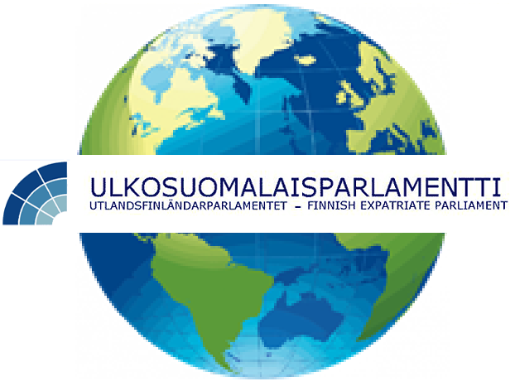

Speakers’ Council 2021-202x
Speaker: Mr Markus Aaltonen (since 25.4.2019)
Deputy Speakers:
Northern Europe:
Ms Seija Sjöstedt

Eastern Europe:
Mr Sakari Neuvonen

Central Europe: Mr Kari Henrik Tumelius
Southern Europe, Africa and the Middle East:
Mr Marko Suomalainen

Swedish speaking Finns around the World:
Ms Barbro Allardt Ljunggren

USA and Latin America:
Ms Hanna Wagner

Canada: Ms Irina Ilmokari
Australia and Asia:
Mr Michael (Mikko) Pekkala

