BY-LAWS – In order to get involved in the FEP activities, a Finnish expatriate organization or association ratifies the FEP By-laws. After ratification, the organization is can send its representative(s) to the FEP Sessions and submit initiatives.
SPEAKERS – The Chairman of the Finland Society is Speaker of the Parliament. The Parliament Session elects eight Deputy Speakers, who represent different regions in the world. The Speakers’ Council, consisting of the Speaker and the eight Deputy Speakers, meet twice a year in Helsinki.
SESSIONS – The FEP convenes every 2-3 years to a parliamentary Session in Helsinki. The 20th anniversary Session in June 2017 at the University of Helsinki adopted 56 resolutions. The 10th Session convenes 11.-12.6.2021 digitally, longdistance (postponed from 2020).
REPRESENTATIVES – Each organization is entitled to send one representative to the Parliament. An organization with more than 500 members may send two representatives. Over 1 000 members allows to send three representatives.
COMMITTEE – Session representatives work in committees. Standing committees include political and official issues, citizenship, senior, social, youth, education and training, culture, financial, information and rules committees.

Finnish Expatriate Parliament is part of:

FINLAND SOCIETY
Mariankatu 8
FI-00170 Helsinki
Finland

Tel: +358 (0)9 6841 210
Home page: suomi-seura.fi

FEP website: usp.fi
FEP e-mail: info@usp.fi

Join us in Facebook:
Ulkosuomalaisparlamentti

THE FINNISH EXPATRIATE PARLIAMENT

A Co-operation Forum and Promoter of Interests for all Finns living abroad
23
USP
1997-2021
20

20

20

UFP
FEP
20

The Finnish Expatriate Parliament (FEP) is a co-operative forum, where Finns living around the world come together and collectively decide on matters they deem important to them.
The FEP is a medium through which the collective decisions of Finnish expatriates are transmitted to the Finnish Government and to relevant non-governmental organizations.
The FEP is a lobbying organization, the purpose of which is to make sure that the views of expatriates are given adequate attention in the Finnish public policy decision making.
The FEP’s activities are based on the initiatives made by Finnish expatriate organizations and on resolutions adopted by the Parliament Session.
The FEP by-laws have been ratified by 540 organizations in 37 countries.

HOW TO GET INVOLVED?

The FEP membership base consists of expatriate Finnish organizations.
The Finnish Expatriate Parliament is open to all Finnish expatriates, whether they carry a Finnish passport or not.
All that is required to participate is a Finnish background and that you are involved in a Finnish expatriate organization, which has ratified the FEP by-laws.
Contact the Deputy Speaker of your region or the Secretariat for more information!
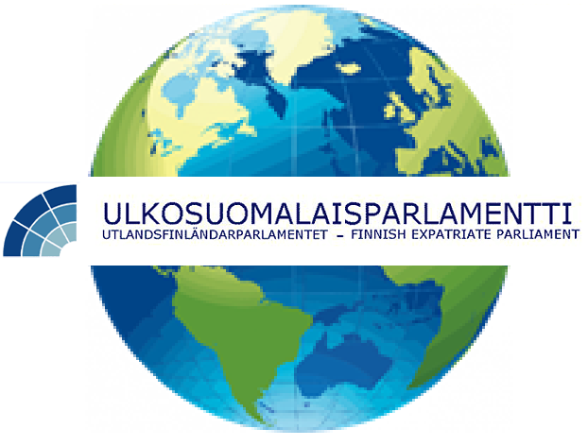

Speakers’ Council 2017-2021
Speaker: Mr Markus Aaltonen (since 25.4.2019)
Deputy Speakers:
Northern Europe:
Ms Seija Sjöstedt

Eastern Europe:
Mr Sakari Neuvonen

Central Europe: Ms. Kati Hognes
Southern Europe, Africa and the Middle East:
Ms Katia Brunetto

Swedish speaking Finns around the World:
Ms Barbro Allardt Ljunggren

USA and Latin America:
Ms Hanna Wagner

Canada: Mr Veli Niinimaa
Australia and Asia:
Mr Michael (Mikko) Pekkala

